Experiment: Implement Minimax Algorithm for Gaming in Python

Aim
To implement the Minimax Algorithm in Python for a two-player game and determine the optimal move for the maximizing player.

Objective
To develop a Python program that uses the Minimax algorithm to evaluate game states and select the best possible move for the maximizing player.

Algorithm
- Start.
- Define the game tree with terminal node values.
- If the current node is a terminal node, return its value.
- If it is the maximizing player's turn:
  - Choose the maximum value from all child nodes.
- If it is the minimizing player's turn:
  - Choose the minimum value from all child nodes.
- Continue recursively until the root node is evaluated.
- Display the optimal value.
- Stop.
FLOWCHART:
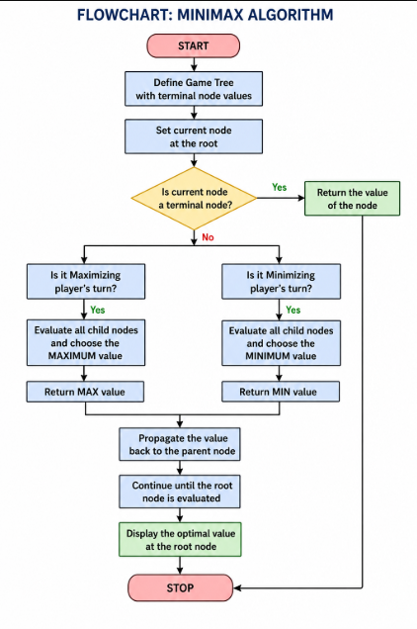
CODE:
# Minimax Algorithm Implementation

import math

# Minimax function
def minimax(depth, nodeIndex, isMax, scores, height):

# Base case: leaf node reached
if depth == height:
return scores[nodeIndex]

if isMax:
return max(
minimax(depth + 1, nodeIndex * 2, False, scores, height),
minimax(depth + 1, nodeIndex * 2 + 1, False, scores, height)
)

else:
return min(
minimax(depth + 1, nodeIndex * 2, True, scores, height),
minimax(depth + 1, nodeIndex * 2 + 1, True, scores, height)
)

# Leaf node values
scores = [3, 5, 2, 9, 12, 5, 23, 23]

# Height of the tree
treeHeight = int(math.log2(len(scores)))

# Execute Minimax
result = minimax(0, 0, True, scores, treeHeight)

print("Optimal Value:", result)
Output:
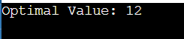
Result:
The Minimax algorithm was successfully implemented in Python and determined the optimal game value for the maximizing player.

Conclusion
The Python program successfully implements the Minimax algorithm, which is widely used in Artificial Intelligence for two-player games such as Tic-Tac-Toe and Chess. The algorithm recursively evaluates all possible game states and guarantees the best move assuming both players play optimally.

